Mario Palacios

CSC 130 – 06

02/15/2019

Console and Questions

\*\*\*\*\*\*\*\*\*\*\*\*\*\*\*\*\*\*\*\*\*\*\*\*\*\*\*\*\*\*\*Here I Will Be Testing The Stack\*\*\*\*\*\*\*\*\*\*\*\*\*\*\*\*\*\*\*\*\*\*\*\*\*\*\*\*\*\*\*

Here I will be testing my individual push methods

It should output C on top, B in the middle, and A at the bottom

C

B

A

The test has passed!

Here I will be testing my individual pop methods

The output will be B on top, with A at the bottom

B

A

The test has passed!

Here I am testing my isEmpty method by printing FALSE if not empty, and TRUE if empty

Im expecting my Stack to print FALSE because I have pushed A and B into it

false

After popping B and A the method will print TRUE

true

The test has passed!

Here I am testing my Constructor for my Stack

the Stack will passing an array

The array has been choosen already to be A,B,C

It should output C on top, B in the middle, and A at the bottom

C

B

A

The test has passed!

I will be testing some edge cases that are meant to break my program

First case: user pushing nothing into the stack.

You entered nothing, please enter a String value

I have entered a message for the user to enter a String value

Second case: user pushes value that is not a String

You entered an int value, please enter a String value

You entered a double value, please enter a String value

You entered a char value, please enter a String value

You entered a boolean value, please enter a String value

I have entered a message for the user to enter a String value

Third Case: popping a value when there is nothing in the Stack

I am expecting for this case to either print null or print nothing at all

Nothing is showing, so popping an empty value will not crash the program :)

Fourth Case: I will push mulitple values (1-7), then pop the top two values and finally print out the Stack

I am expecting to print out values 1-5, starting 5 on top and ending with 1 at the bottom

5

4

3

2

1

The edge cases have been dealt with!

\*\*\*\*\*\*\*\*\*\*\*\*\*\*\*\*\*\*\*\*\*\*\*\*\*\*\*\*\*\*\*Here I Will Be Testing The Queue\*\*\*\*\*\*\*\*\*\*\*\*\*\*\*\*\*\*\*\*\*\*\*\*\*\*\*\*\*\*\*

Here I will be testing my individual enqueue method

It should output X on top, Y in the middle, and Z at the bottom

X

Y

Z

The test has passed!

Here I will be testing my individual dequeue method

The output will be Y on top, with Z at the bottom

Y

Z

The test has passed!

Here I am testing my isEmpty method by printing FALSE if not empty, and TRUE if empty

Im expecting my Queue to print FALSE because I have pushed Y and Z into it

false

After popping Y and Z the method will print TRUE

true

The test has passed!

Here I am testing my Constructor for my Queue

the Queue will passing an array

The array has been choosen already to be X,Y,Z

It should output X on top, Y in the middle, and Z at the bottom

X

Y

Z

The test has passed!

I will be testing some edge cases that are meant to break my program

First case: user pushing nothing into the stack.

You entered nothing, please enter a String value

I have entered a message for the user to enter a String value

Second case: user pushes value that is not a String

You entered an int value, please enter a String value

You entered a double value, please enter a String value

You entered a character value, please enter a String value

You entered a boolean value, please enter a String value

I have entered a message for the user to enter a String value

Third Case: I will dequeue a value when there is nothing in the Queue

I am expecting for this case to either print null or print nothing at all

Nothing is showing, so when you dequeue an empty value it will not crash the program :)

Fourth Case: I will enqueue mulitple values (1-7), then dequeue the top two values and finally print out the Queue

I am expecting to print out values 3-7, starting with 3 on top and 7 at the bottom

3

4

5

6

7

The edge cases have been dealt with!

1) Show an example screenshot of how you used the debugger in fixing your code with a short description on explaining the bug and how you fixed it.

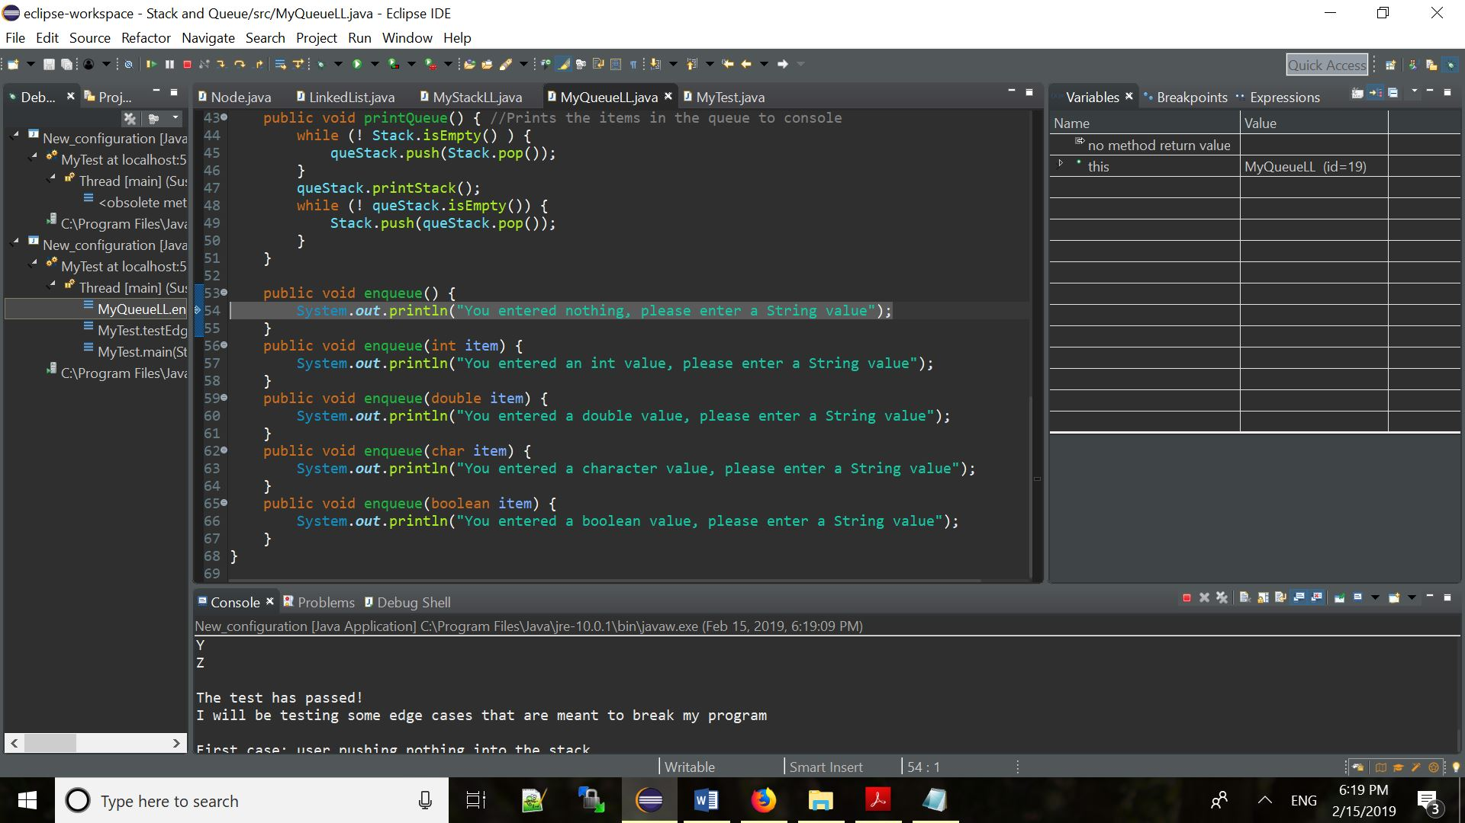

The bug in this code was that when I passed an empty enqueue the program would crash and not produce anything. To fix it I created an empty enqueue method that would print out a message telling the user nothing was in Queue and to pass a String Value.

2) What is the runtime MyStack's push method, in Big O?

- The runtime of my MyStack’s push is O(1) because this method uses a single LinkedList which goes through each individual node. It also creates a new node and links with another node once the user pushes more values, therefore it is moving at a constant rate of O(1).

3) What is the runtime MyQueue's dequeue method, in Big O?

- The runtime of MyQueue’s dequeue method is O(n) because it has to pop all the elements from Stack and push them to queStack one by one.

4) What is the space complexity of MyQueue, in Big O?

- MyQueue space complexity is O(n) because the user can create a queue with as many elements they want, with the only boundary being themselves. So as a result it grows the LinkedList “n” tines.